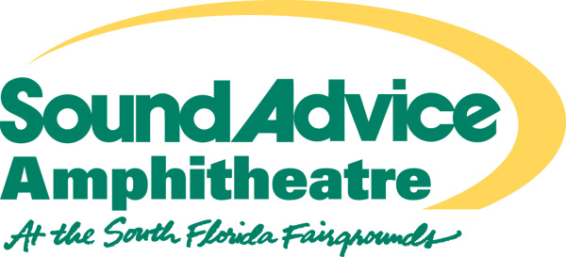

FOR IMMEDIATE RELEASE
CONTACT: Woody Graber
(305) 606-2979 (cell)

OZZFEST CANCELLED
IN WEST PALM BEACH!

Due to the approach of Hurricane Frances, the Ozzfest concert scheduled for Saturday, September 4th at Sound Advice Amphitheatre in West Palm Beach, FL has been cancelled. Tickets will be refunded at point of purchase. Tickets are still available for today’s (Thursday, September 2nd) show at the Ford Amphitheatre in Tampa, FL.

###

